**ELASTIC LOAD BALANCING**

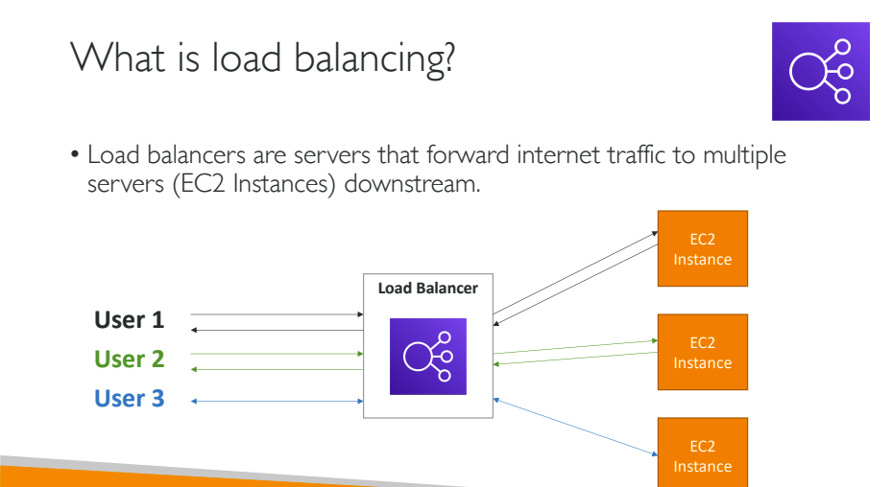

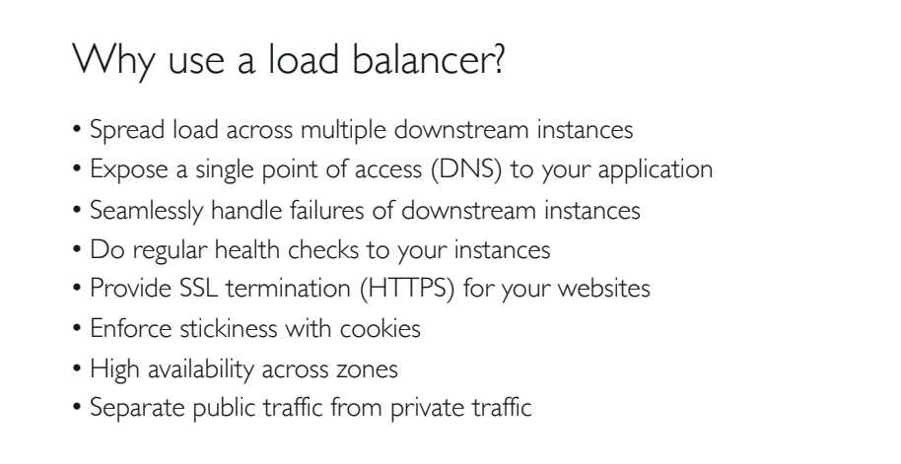

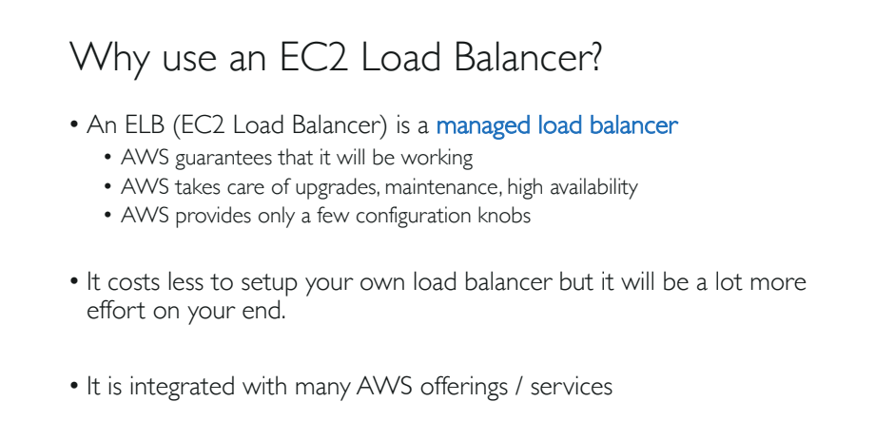

**NOTE**: Both LB and ASG provides High Availability.

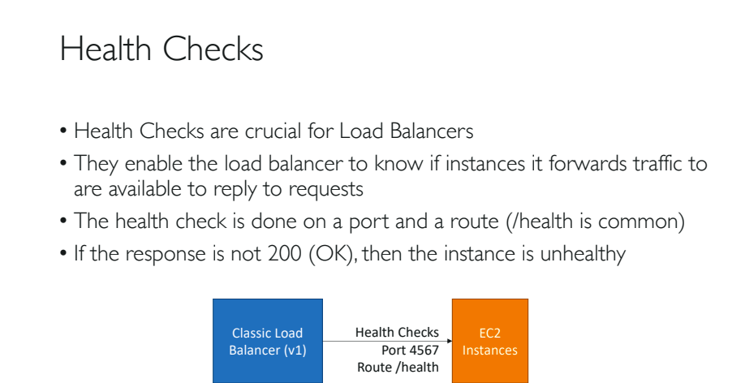

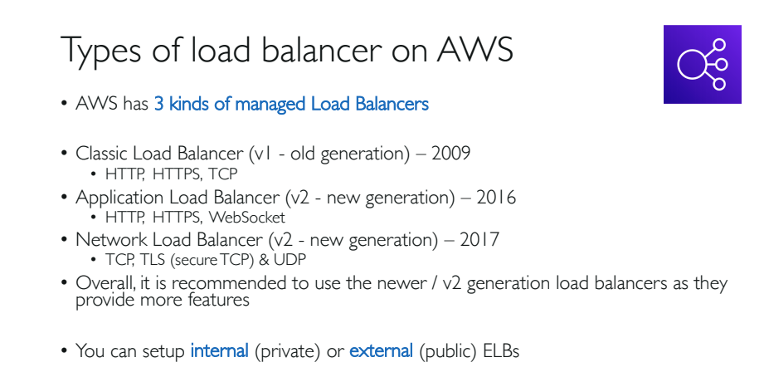

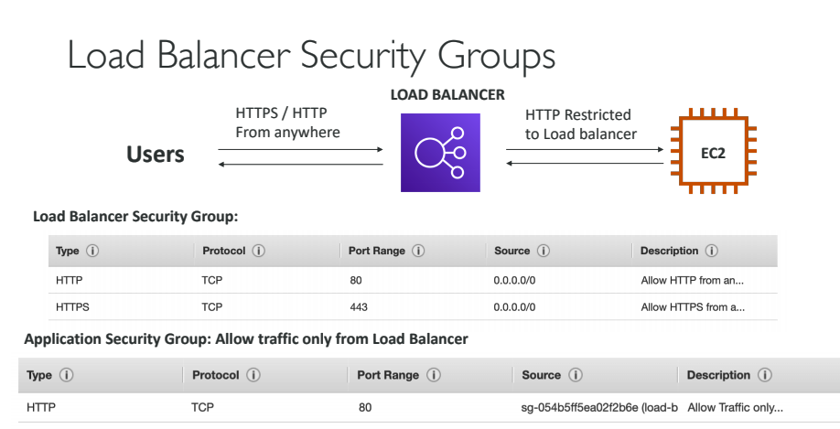

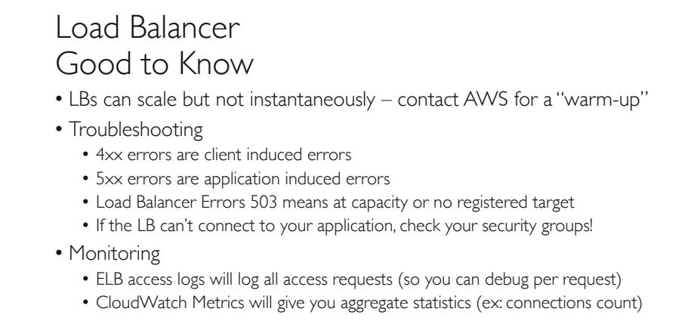

**NOTE**: ELB charges on hourly basis. So delete the ELB when you are done working with ELB.

**ELB Listeners:**

1. By default ELB’s are Region Specific.
2. An ELB listener is a process that checks for connection request.
3. HTTP, HTTPS, TCP and SSL are the requests can be served under an ELB.
4. If any ICMP request (ping) is requested, than ELB cannot process that request, instead, the request will be directly made to the instance.
5. ELB listeners can be categorized into Frontend Listeners and Backend Listeners.
6. Frontend listeners check for traffic from client.
7. Backend listeners decide to which instance the traffic should be distributed.
8. ELB processes only inbound traffic of specific requests mentioned in point 3.
9. ELB has nothing to do with the outbound traffic. Instances will communicate on their own.
10. Before you delete the ELB, it is recommended that all the instances under the ELB should be handed over to Route-53, so that the upcoming requests for these instances will be redirected by Route-53.

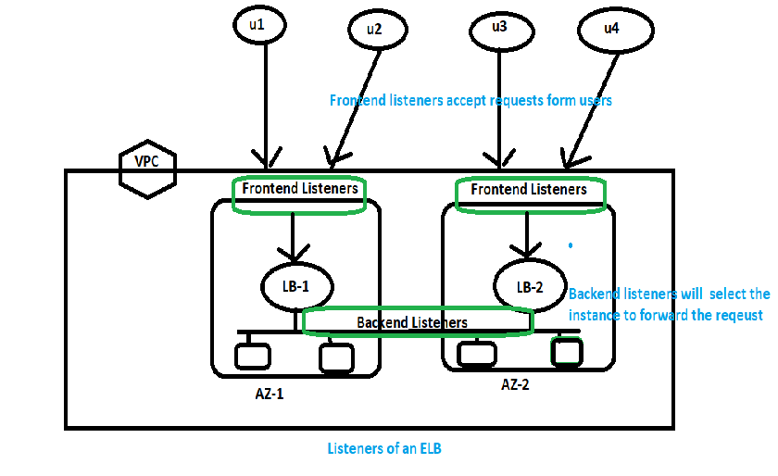

**NOTE:** If ELB is deleted, than the registered instances will not be deleted, instead they start to work on their own.

**Un-healthy and Healthy Instances:**

1. ELB supports only IPv4 address only in a VPC.
2. Ensure that the subnet defined for the ELB is at least /27 or below in size, and has at least 8 available IP addresses available for instances under ELB.
3. If possible try to maintain same no of instances in each AZ per ELB.(Cross Zone LB policy)
4. ELB monitors the health of the instances and routes traffic to healthy instances only.
5. By default, AWS console uses ‘ping HTTP’ at port 80, to health check the instances.
6. Registered healthy instances must respond with a **HTTP ‘200 OK’** message within the timeout period, else the instance will be considered as unhealthy.
7. **Default ‘Response Timeout’** is: Default 5sec (range is 2 to 60 sec).
8. **Health Check Interval**: Default 30sec, (range is 5 to 300 sec).
9. **Unhealthy Threshold**: Number of consecutive failed health checks that should occur before the instance is declared unhealthy.

Range is: 2 to 10

Default: 2

1. **Healthy Threshold**: No of consecutive successful health checks that should occur before the instance is declared healthy.

Range is: 2 to 10

Default: 10

**Cross Zone Load Balancing:**

1. By default ELB distributes traffic evenly between the AZ it is defined in, without considering the number of EC2 instances in each AZ.
2. The problem with the above type of approach is, if a 3 AZ’s has 2, 3, and 4 instances in each AZ, than ELB distributes traffic equally to all the AZ’s. But logically the load on AZ3 with 4 instances is less, when compared to the AZ1 which contains only 2 instances. But both AZ’s are being shared by equal amount of load.
3. The solution to the above problem is Cross Zone Load balancing.
4. By default this Cross Zone LB is disabled.
5. When CZLB is enabled, the ELB will distribute traffic evenly between registered EC2 instances.

Example:

Imaging 3 availability zones having: AZ1-> 2instances, AZ2->4 instances, AZ3-> 4instances

CZLB load distribution: 2+4+4 = 10

100% of work/10 instances = 10% of work for each instance

AZ1 = 20% of load

AZ2 = 40% of load

AZ3 = 40% of load

1. ELB names should be unique within an account.
2. ELB is region specific: Means LB made in Mumbai cannot load balance in Virginia.
3. If you try to register an instance in an AZ with ELB, but not defined the respective subnet in that AZ for the ELB, than these instances will not receive traffic from the ELB.

**Explanation**: If **Inst1** is an instance, and **MyLB** is a LB, **sub1** is a subnet of the instance Inst1 from **AZ1**. Then **MyLB** should know about **sub1** of **AZ1**.

1. ELB is always accessed through DNS, but not by its IP.
2. An ELB can be internet facing(uses public ip addresses) or Internal ELB(used private ip addresses).

Target Groups:

1. Logical grouping of targets(instances) under LB.
2. Target Groups can exist independently from LB.
3. TG can be associated with Auto-Scaling Group.
4. A TG can contain up to 200 targets.